The Nebula Federation
Horsford CE VA Primary School


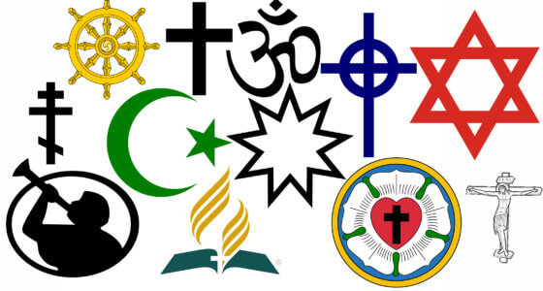
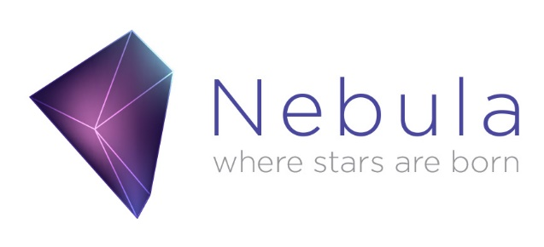
Curriculum Skills and Progression Map Religious Education: 2025 to 2026
Contents:
- RE statement of intent
- Christian Distinctiveness Statement
- RE as a multi-disciplinary Subject
Theology Age Related Expectations and Theology Core Questions from the Agreed Syllabus 2019
Philosophy Age Related Expectations and Philosophy Core Questions from the Agreed Syllabus 2019
Human and Social Sciences Age-Related Expectations and Core Questions from the Agreed Syllabus 2019.
- Core Knowledge Tables (incorporating key vocabulary):
  - Christianity
  - Hinduism
  - Islam
  - Judaism
  - Humanism
  - Notes about Buddhism and Sikhism
- Essential Vocabulary
- Writing Opportunities
- Current RE Long Term Plan
- Examples of ‘deeper thinking’ questions

Section 1 R.E. Statement of Intent

Religious Education at Horsford CE VA Primary School aims to develop religious literacy for all pupils. In the Foundation Stage pupils begin to explore religion and worldviews in terms of important people, times, places and objects, and, when possible, visit places of worship. Pupils listen to, and talk about, religious stories which may raise puzzling and interesting questions. They are introduced to specialist words and use their senses in exploring religious beliefs, practices and forms of expression. In Key Stage 1, there is a two-year rolling programme, where the children cover central a range of Christian and Judaism beliefs and practices. Whilst other religions are mentioned, e.g. Diwali in the unit ‘Why is light an important symbol?’, the focus is on Christianity and Judaism, with the aim being to give the children a firm basis which, as they progress through the school, can then be applied to other religions and worldviews, and also in studying Christianity in more depth. In Years 3 and 4, there is also a two-year rolling programme. The pupils continue to explore the central beliefs, as well as practices of Christianity and also study Islam in depth, as well as covering a little more of Hinduism. The children also learn about how the lives of people from different faiths are shaped by their beliefs. In years 5 and 6, a two-year rolling programme is also used. Hinduism is studied in greater depth and the children are provided with opportunities for more critical examination of different beliefs. They study the work of philosophers and encounter worldviews like Humanism. The pupils also look more closely at the spiritual and moral questions humans tackle throughout their lives, encouraging children to draw on their knowledge from previous years to enable them to become ‘deeper thinkers’.
Between the beginning of Key Stage 1 and end of Key Stage 2, there is a balance of ‘lenses’ identified in the locally agreed syllabus. Two units are covered in the Autumn and Summer Term, while one unit is covered in the Spring Term – the Spring Term units have been chosen for the term as they provide opportunities for more ‘in depth’ study and coverage, rather than trying to fit two units in this term, which is often shorter than the two outer terms. By the end of Key Stage 2, the children will have covered thirty units: ten with a theology focus, ten with a philosophy focus and ten with a human/social science focus. Each unit provides a link with one of the school’s values.

Section 2 Christian Distinctiveness Statement

The Religious Education Curriculum and Christian Distinctiveness
at Horsford CofE VA Primary School

At Horsford CE VA Primary School, the purpose of our R.E. curriculum is to enable the children to develop religious literacy. We believe that this will help the children to have a greater understanding of people of different religious beliefs and those who have none. We believe that through a greater understanding of each other within our school and the wider community, the children will have the courage to express their beliefs. We believe that this subject allows the children to show compassion towards others by learning stories and about people from different religions and being able to put into practice what they have learnt – particularly through our school’s chosen story of ‘The Good Samaritan’. We believe that R.E. helps the children develop responsibility to express their beliefs and to challenge beliefs which are contrary to our school’s vision.

‘Spirituality is the bitter-sweet yearning for beauty, truth, love and wonder beyond ourselves. It is a longing we pursue together and a treasure we glimpse in ourselves and one another and seek beyond us into eternity. It is life in all its fullness.’

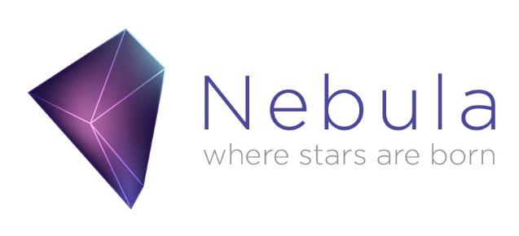

The Religious Education Curriculum and Provision for Pupils with SEND

At Horsford C of E VA Primary school, we believe all pupils should have the opportunity to learn to the best of their capabilities through a broad and balanced, inclusive curriculum. For our pupils with a Special Educational Need, we scaffold their learning to provide them with the strongest opportunities for success in our school. We believe firmly in the SEND Code of Practice's statement that 'every teacher is a teacher of SEN' and that our pupils with SEN should be provided with the same opportunities as their peers in our school. This means that, with their learning being personalised to meet their areas of need, they feel included in the classroom and make progress year on year. Reasonable adjustments are made in all lessons to enable this.

The Religious Education curriculum can be adapted to meet the needs of children with SEND in the following ways.
Word Banks for pre-learning and to support during topics and themes | Printing work larger and in smaller chunks
Cutting and Sticking Key Words on to work as prompts | Cloze passages/activities to check learning
Print out portions of work and learning objectives to minimise writing | Draw answers or explanations
Coloured Paper or recycled paper to minimise visual stress | Visual Timetables – class and individual
Breaking down lessons into short, manageable chunks | Coloured Paper for visual stress
Mixed ability groups – using peers as support and role models | Writing frames and scaffolding
Adult assistance nearby | Word lists of key vocabulary for pre-learning and as prompts
Using another student as a reader/support | Relevant word banks of common language for different subjects
Knowledge map/Mind Maps | Trying a 1:1 adult/adult nearby
Recording ideas on whiteboards as an aide memoire | Checking seating position – sight problems – near the back for sensory needs
Recording devices to record their answers/sentences – talking tins, iPad

When planning for Religious Education class teachers should adapt their lessons where necessary using ideas taken from this list, however it is important to remember this list is not exhaustive and other adaptations may be needed for children with specific needs.

Section 3 – R.E. as a multi- disciplinary subject:
Our curriculum RE is rooted in three disciplines. These are theology, philosophy and the human/social sciences, the latter of which is a collection of disciplines. Our progression map shows how skills within each of these disciplines are developed across the key stages.

Religious Education Skills Map
EYFS
RE in EYFS will prepare children for the multi-disciplinary approach.

Pupils begin to explore the world of religion and belief in terms of special people, times, places and objects. They listen to, and talk about, religious stories which may raise interesting questions. They are introduced to specialist words and use their senses in exploring religious beliefs, practices and forms of expression.

People and Communities ELG
• Know some similarities and differences between different religious and cultural communities in this country, drawing on their experiences and what has been read in class.
The children will be exposed to Christianity and at least one other religion, religious belief or worldview
Theology: Thinking through believing |  | Philosophy: Thinking through believing |  |  | Human/Social Sciences: Thinking through living
Pupils can … |  | Pupils can … |  |  | Pupils can …
- Recognise simple religious beliefs or teachings  - Talk about some aspects of a religious or belief story  - Introduce key theological vocabulary such as ‘God’.  - Recreate religious and belief stories through small world play. |  | - Recognise simple religious beliefs or teachings  - Talk about some aspects of a religious or belief story  - Introduce key theological vocabulary such as ‘God’.  - Recreate religious and belief stories through small world play. |  |  | - Identify simple features of religious life and practice in a family context  - Recognise a number of religious words  - Name some religious symbols  - Name some religious artefacts  - Talk about religious events that they see or hear about e.g. festivals, ceremonies  - Talk about what people wear because of their beliefs  - Be visited by a person from a local place of worship  - Talk to someone who holds a particular religious belief
Key Vocabulary
Beliefs  Bible  Celebration | Christian  Christmas  Church |  | Different  Easter  Festivals | God  Hinduism  Religions |  | Similar  Symbols  Worship

Religious Education Skills Map
KS1 and KS2
Religious Education – Theology – Pupils can …
Theology | Year 1 | Year 2 | Year 3 | Year 4 | Year 5 | Year 6
A.  Where beliefs come from | Give a clear, simple account of at least one narrative, story or important text used by at least one religion or worldview | Retell a narrative, story or important text from at least one religion or worldview and recognise a link with a belief  Recognise different types of writing from within one text | Show awareness of different sources of authority and how they link with beliefs.  Identify different types of writing and give an example of how a believer might interpret a source of authority | Identify different sources of authority and how they link with beliefs.  Give examples of different writings and different ways in believers interpret sources of authority | Describe different sources of authority and how they link with beliefs.  Describe a range of different interpretations of sources of authority and consider the reliability of these sources for a group of believers. | Explain different sources of authority and the connections with beliefs.  Begin to discuss the reliability and authenticity of texts that are authoritative for a group of believers.
B.  How beliefs change over time | N/A | N/A | Recognise that beliefs are influenced by events in the past and present | Identify events in history and society which have influenced some religious and non-religious worldviews | Describe how events in history and society have influenced some religious and non-religious worldviews | Explain how events in history and society have influenced some religious and non-religious worldviews
C.  How beliefs relate to each other | Recognise that narratives, stories and texts used by at least one religion or worldview contain beliefs. | Recognise that some beliefs connect together and begin to talk about these connections. | Identify some links between beliefs being studied within a religion or worldview.  Show awareness of some of the similarities and differences between and within religions and worldviews. | Make clear links between different beliefs being studied within a religion or worldview.  Identify some of the similarities and differences between and within religions and worldviews | Describe the connections between different beliefs being studied and link them to sources of authority  Describe some of the key theological similarities and differences between and within religions and worldviews | Explain connections different beliefs being studied and link them to sources of authority using theological terms  Explain the key theological similarities and differences between and within religions and worldviews
D.  How beliefs shape the way believers see the world and each other | Give an example of how ______ use beliefs to guide their daily lives | Give different examples of how ______ beliefs influence daily life | Recognise ways in which beliefs might make a ______ think about how they live their life, how they see the world in which they live and how they view others | Identify ways in which beliefs might make a ______ think about how they live their life, how they see the world in which they live and how they view others | Describe ways in which beliefs shape the way _______ view the world in which they live and how they view others | Explain and discuss how beliefs shape the way ______ view the world in which they live and how they view others

KS1 Core Questions | KS2 Core Questions
- What do religious people say God is like?  - Why is light an important symbol for many religious believers?  - What do XXXX remember at XXXX? E.g. what do Jews remember at Passover?  - What might XXXX learn from the XXXX narrative? E.g. what might Hindus learn from the Diwali narrative?  - What might xxxx learn from the story of xxxxx? E.g. what might Jews learn about God from the story of Abraham?  - What do Christians believe God is like?  - Who made the world?  - Why does Christmas matter to Christians?  - Why does Easter matter to Christians? | - What do XXXX believe about God?  - How do XXX explain the suffering in the world?  - What is the bible and how do people interpret it?  - How reliable are sources of authority for believers?  - Why is there so much diversity of belief within XXXX?  - Where do religious beliefs come from?  - How have events in history shaped beliefs?  - One narrative, many beliefs? Why do people interpret things differently?  - What do Christians learn from the creation story?  - What is the Trinity?  - Why to Christians call the day Jesus died ‘Good Friday’?  - What does it mean if God is holy and loving?  - Creation and science: Conflicting or complementary?  - Was Jesus the Messiah?  - What did Jesus do to save human beings?  - What differences doe the resurrection make for Christians?

Religious Education Skills Map
KS1 and KS2
Religious Education – Philosophy – Pupils can …
Philosophy | Year 1 |  | Year 2 | Year 3 | Year 4 | Year 5 | Year 6
A.  The Nature of knowledge, meaning and existence | Ask questions about the world around them and talk about these questions.  Begin to make connections between using their senses and what they know about the world around them. | Talk about the questions a story or practice from a religion or worldview might make them ask about the world around them  Talk about what people mean when they say they ‘know’ something. |  | Recognise that there are many different religious and non-religious answers to questions people raise about the world around them  Talk about the difference between knowing and believing. | Describe different philosophical answers to questions about the world around them, including questions relating to meaning and existence  Begin to use philosophical vocabulary when discussing issues relating to truth, reality and knowledge. | Explain different philosophical answers to questions about the world around them, including questions relating to meaning and existence.  Explain some of the different ways in which philosophers understand abstract concepts. | Begin to analyse and evaluate a range of philosophical answers to questions about the world around them, including questions relating to meaning and existence  Begin to analyse and evaluate different ways in which philosophers understand abstract concepts.
B.  How and whether things make sense | Give a simple reason using the word ‘because’ when talking about religion and belief | Give a reason to say why someone might hold a particular belief using the word ‘because’ |  | Decide if a reason or argument based on a religion or belief makes sense to them and is expressed clearly.  Use more than one reason to support their view. | Begin to weigh up whether different reasons and arguments are expressed coherently when studying religion and belief  Give reasons for more than one point of view, providing pieces of evidence to support these views | Explain, using a range of reasons, whether a position or argument is coherent and logical.  Link a range of different pieces of evidence together to form a coherent argument | Begin to analyse and evaluate whether a position or argument is coherent and logical and show increasing awareness of divergence of opinion.  Use well-chosen pieces of evidence to support and counter a particular argument
C.  Issues of right and wrong, good and bad | Using religious and belief stories to talk about how beliefs impact on how people behave | Using religious and belief stories, make connections between peoples’ beliefs about right and wrong and their actions. |  | Recognise that it is difficult to define ‘right’, ‘wrong’, ‘good’ and ‘bad’.  Recognise some of the similarities and differences between these ideas. | Describe a range of answers to ethical and moral questions, showing awareness of the diversity of opinion and why there are differences. | Explain a range of answers to ethical and moral questions and issues, drawing conclusions and showing awareness of diversity of opinion and why there are differences. | Begin to analyse and evaluate a range of different answers to ethical and moral questions/issues, showing an understanding of the connections between beliefs, practices and behaviour.

KS1 Core Questions | KS2 Core Questions
- Why do people have different views about the idea of ‘God’?  - What do my senses tell me about the world of religion and belief?  - What is puzzling about the world of religion and belief?  - What is ‘good’ and what is ‘bad’?  - How do people decide what is right and wrong?  - What questions do religious stories make us ask? Can we find any answers?  - What’s the big idea? (introduction to philosophy/Socratic dialogue) | - Why is there suffering in the world?  - What is the difference between believing and knowing?  - What do we mean by ‘truth’?  - What can we learn about the world/knowledge/meaning of life from the great philosophers?  - How do people make moral decisions?  - How do people respond to issues of poverty and justice?  - What does it mean to be ‘human’?  - What kind of world should we live in?  - Is seeing believing?  - Can kindness change the world?  - Is being happy the greatest purpose in life?  - Is believing in God reasonable?

Curriculum Skills and Progression Map
Religious Education – Human/Social Sciences – Pupils can …
Human/Social Sciences | Year 1 | Year 2 | Year 3 | Year 4 | Year 5 | Year 6
The diverse nature of religion | Recognise that people have different beliefs and that some people follow religions and others non-religious worldviews | Recognise the names of different religions, religious beliefs and worldviews and use them correctly. | Identify some of the ways people use the terms ‘religion’ and ‘belief’ when exploring religions, beliefs and worldviews. | Describe the difference between the terms ‘religion’ and ’belief’ when exploring religions, beliefs and worldviews. | Explain the different ways in which the terms ‘religion’ and ‘’belief’ are used by followers from within a religion or worldview and those from outside it.  Show awareness that talking about religion and belief can be complex. | Begin to analyse and evaluate the varying use of the terms ‘religion’ and ‘belief’ by followers from within a religion or worldview and those from outside it.  Recognise some areas of controversy when interpreting and explaining the nature of religion and belief.
Diverse ways in which people practice and express beliefs | Recognise some of the symbols, artefacts and practices used by people of different religions and beliefs in the local area | Identify evidence of religion and belief especially in the local area. | Identify some similarities and differences in how people practise and express beliefs both within and between at least two different religions/worldviews. | Describe some of the varying ways in which religions and beliefs are practised locally and nationally (both within and between religions/worldviews) with reference to at least two religions/worldviews. | Explain some of the varying ways in which religions and beliefs are practised locally and nationally (both within and between religions/worldviews) with reference to at least two different religions/worldviews. | Begin to analyse and evaluate the varying ways in which religions and beliefs are practised locally, nationally and globally (both within and between religions/worldviews) with reference to at least two different religions/worldviews.
The ways in which beliefs shape individual identity, and impact on communities and society and vice versa | Recognise that beliefs can have an impact on a believer’s daily life, their family or local community. | Identify ways in which beliefs can have an impact on a believer’s daily life, their family or local community. | Identify a range of ways in which beliefs can have an impact on a believer’s daily life, their family, community and society. | Describe ways in which beliefs can impact on and influence individual lives, communities and society and show awareness of how individuals, communities and society can also shape beliefs. | Explain how beliefs impact on and influence individual lives, communities and society, and how individuals, communities and society can also shape beliefs. | Begin to analyse and evaluate how beliefs impact on, influence and change individual lives, communities and society, and how individuals, communities and society can also shape beliefs.

KS1 Core Questions | KS2 Core Questions
- How do festivals/celebrations bring people together?  - Where is the religion around us?  - What does it mean to belong to the XXXX community?  - What happens in the daily life of a XXXX?  - What does it mean to be part of a religious family?  - Why are symbols and artefacts important to some people?  - How do worship gatherings/ceremonies give xxxx a sense of identity and belonging? | - What do we mean by religion? What makes a religion a religion?  - Does religion bring peace, conflict or both?  - How do beliefs shape identity for XXXX?  - What can we learn from different members/expressions of the XXXX tradition?  - How have expressions of XXXX changed over time?  - How do XXXX express their religious beliefs in modern Britain and in XXXX (name of country)?  - What does it mean to be part of a global religious/worldview community?  - How do people express commitment to a religion or worldview in different ways?  - What difference does being a XXXX make to daily life?  - How do/have religious groups contribute to society and culture?

Section 4: Core Knowledge Tables
Suggested Core Knowledge for Christianity
Disciplinary Lens | Key Stage 1 | Key Stage 2
Theology:
Thinking through believing.  Theology enables pupils to grapple with questions that have been raised by religions and beliefs over the centuries.  It looks at where beliefs come from, how they have changed over time, how they are applied differently in different contexts and how they relate to each other. It involves investigating key texts and traditions within different religions and belief systems, exploring the ways in which they have been used as authoritative for believers and the ways in which they have been challenged, interpreted and disregarded over time. It assesses the key ideas of a religion or belief system as well as exploring the significance of experience on the claims made by religious and non-religious people. | Systematic Theology:  Creation: Christian belief in God as creator of the universe.  God: Christian belief in God as a Father.  Jesus: Awareness of Jesus as an historical figure and of some of his teachings and miracles.  Incarnation: The Nativity narratives in Luke and Matthew. The Christian belief that God became human in Jesus.  Salvation: The Easter narrative and Christian belief that Jesus builds a bridge between God and humans. Recognition of how incarnation and salvation relate to one another for Christians.  Textual Theology:  The Bible as a sacred text for Christians. Recognition of different genre in the bible e.g. parables, letters, history | Systematic Theology:  Creation and Fall: Christian belief that humans are made in God’s image but became sinful and need saving. Introducing debates about the relationship between the Genesis narratives and scientific explanations.  God: Christian belief in one God, who is described as Trinity (Father, Son, Holy Spirit). Sources of authority which explain to Christians the nature of God e.g. bible, experience, creeds.  Jesus: As God incarnate, also known as the Son of God. Christian belief that Jesus fulfilled prophecies about the Messiah.  Incarnation: Jesus as one of the three persons of the Trinity.  Salvation: Gospel accounts of Jesus’ death and resurrection and the various interpretations of these accounts in terms of the meaning of salvation (e.g. forgiveness, sacrifice, redemption)  Textual Theology:  Consideration of genre, author, context, reliability and audience in relation to the Bible, creeds and Christian tradition.  Different interpretations of belief through for example art, music, blogs.  Historical Theology:  Examples of key teachings from religious teachers such as Martin Luther King, Oscar Romero, William Wilberforce. Examples of how experiences have impacted on beliefs e.g the conversion of Saul on the road to Damascus.  Examples of how events in society have influenced beliefs e.g. the persecution of Christians, the abolition movement.

Disciplinary Lens | Key Stage 1 | Key Stage 2
Philosophy:
Thinking through thinking.  Philosophy enables pupils to grapple with questions that have been raised about knowledge, meaning, existence and morality.  It is about finding out how and whether things make sense. It deals with questions of morality and ethics. It takes seriously questions about reality, knowledge and existence. It is the process of reasoning that lies at the heart of philosophy. Studying the works of great philosophers is part of developing an understanding of philosophy. Philosophy contains three fields of enquiry that would be applicable to a balanced framework for RE these are metaphysics, logic and moral philosophy | Metaphysics:  The word ‘God’ as a name.  The nature of a question  The meaning of the word ‘know’.  Awareness of the world around them through the senses  Logic:  The nature of a reason  Use of the word ‘because’  Recognise a reason in a religious or belief text  Moral Philosophy:  Make links between belief and behaviour, particularly through the study of religious and belief narratives.  How people make decisions e.g. impact of family and rules. | Metaphysics:  Varying views about the existence of God  Varying views about the reasons for suffering in the world, including awareness of different types of suffering  Difference between knowledge, belief and opinion.  The complex nature of concepts such as truth, reality, happiness, identity, hope, justice.  An example of a philosopher from the Christian tradition e.g. Augustine  Logic:  The nature of a philosophical question  Debates about whether some things can be proven  The nature of a coherent and reasoned argument  Awareness of divergence of opinion  Creation of balanced arguments  Moral Philosophy:  Influences on moral decision making such as experience, family, history, culture or community (including religious communities).  Introduction to ethical theory such as utilitarianism or hedonism.  Making connections with theological understandings of right and wrong.  Investigation of moral issues such as poverty and wealth, peace and conflict or justice and injustice.

Disciplinary Lens | Key Stage 1 | Key Stage 2
Human /Social Sciences:
Thinking through living.  The human/social sciences enable pupils to grapple with questions about the lived and diversity reality of religion and belief in the world.  It explores the diverse ways in which people practise their beliefs. It engages with the impact of beliefs on individuals, communities and societies. Pupils will investigate the ways in which religions, beliefs and religious believers have shaped and continue to shape societies around the world. They can promote better understanding of the ways in which religions and beliefs influence people’s understanding of power, gender, compassion, and so on. It also enables pupils to consider the nature of religion itself and the diverse ways in which people understand the term ‘religion’. | Nature of Religion:  The use of the term ‘Christian’ and what it means  The term ‘religion’.  The idea that some people follow a set of beliefs, creed or way of life.  Practices and Expression:  The local church (eg): how they are used, worship that takes place. Norwich Anglican and Roman Catholic Cathedrals as a places of importance for many Christians.  Symbolism and artefacts: The cross as a symbol. Artefacts used by Christians such the rosary, paschal candle, chalice and paten.  Use of water and light in ceremonies such as baptism and Christingle.  Individual, community and Society:  The importance of rites of passage such as baptism or First communion for some Christians.  The importance of worship gatherings for Christians e.g. sharing bread and wine, keeping Sunday as a special day  The role of celebrations such as Christmas and Easter in bringing the religious community together. | Nature of Religion:  Different ways in which people understand the term ‘religion’ both within and outside of religious adherence.  The use of term ‘religion’ by Christians, and awareness that some prefer not to use this term.  Christianity originally known as ‘The Way’ in New Testament times.  Awareness of the diverse nature of Christianity locally, nationally and globally.  Practices and Expression:  The church: Church as a global community of Christian believers, the main characteristics of different denominations. Awareness of different denominations locally e.g. Anglican, Roman Catholic, Baptist, Methodist, Free Church, Salvation Army…  Worship: Different expressions of Christian worship including for example the Eucharist and pilgrimage.  Festivals: The diverse ways in which people celebrate festivals such as Christmas, Easter and Pentecost; in particular contrasting two different contexts such as local/global or rural/urban.  Individuals: Meeting individual Christians to ask them about their beliefs and practices.  Individual, community and society:  The impact of Christian teachings on daily life such as providing guidance, reassurance or comfort.  The importance of rites of passage in terms of religious identity e.g. baptism, confirmation  The life and work of a Christian individual whose faith impacts (or impacted) on their actions e.g. Martin Luther King, Mother Teresa, Desmond Tutu, Wilberforce, Edith Cavell, Oscar Romero  Varying expressions of prayer including for example the ‘Thy Kingdom Come’, Taize, 24/7 prayer or Prayer Spaces.  Varying cultural expressions of the Christian faith as seen through art and/or music.  The role of the Christian community in charity work such as Foodbanks or Christian Aid.

Suggested Core Knowledge for Hinduism
Disciplinary Lens | Key Stage 1 | Key Stage 2
Theology:
Thinking through believing.  Theology enables pupils to grapple with questions that have been raised by religions and beliefs over the centuries.  It looks at where beliefs come from, how they have changed over time, how they are applied differently in different contexts and how they relate to each other. It involves investigating key texts and traditions within different religions and belief systems, exploring the ways in which they have been used as authoritative for believers and the ways in which they have been challenged, interpreted and disregarded over time. It assesses the key ideas of a religion or belief system as well as exploring the significance of experience on the claims made by religious and non-religious people. | Hinduism is not studied in KS1 at Horsford | Systematic Theology:  God: Hindu beliefs in one God, usually referred to as spirit (Brahman) represented through different names and images. Brahman as Supreme Reality who pervades all creation through stories from the Upanishads. Awareness of the Trimurti- Brahma, Shiva, Vishnu.  Atman: The name used for the essential nature of humans or their soul  Avatars: Name avatars such as Rama, Krishna and Ganesha and talk about stories associated with them and the beliefs and values arising from them; the belief that Vishnu takes form and comes to earth. The word literally meaning ‘descent’. The 10 avatars including Lord Krishna and Lord Rama, and the beliefs and values arising from narratives about them.  Ahimsa: Non-violence springs naturally from the Hindu belief of unity in diversity.  Samsara: The cycle of birth and rebirth which ends when a personal discovers his or her essential spirit, called Moksha. Hindus believe that consciousness is present in all life forms.  Karma: The law of karma is linked to the theory of reincarnation. It states that there are consequences for actions beyond this life. The law of cause and effect.  Textual Theology:  Hindu holy books are written in Sanskrit and come in the form of laws, hymns and poetry; the oral tradition in the Indus valley and the writing down of teaching in the Vedas which contains hymns and prayers.  The Ramayana as a sacred poem about Rama and Sita; consideration of genre, author, context, reliability and audience in relation to the Vedas, Ramayana, Mahabharata Upanishads, and Puranas.  Different interpretations of belief through for example through worship, dance and storytelling.  Interpretation of prayers such as the Gayatri Mantra.  Historical Theology:  Examples of key teachings from religious teachers, e.g.Gandhi, Swaminarayan, Sai Baba, Srila Prabhupada, Sri Ramakrishna  Examples of how experiences have impacted on beliefs e.g the life of Mahatma Gandhi.  Impact of the spread of the Hindu tradition to the West on how beliefs are understood.

Disciplinary Lens | Key Stage 1 | Key Stage 2
Philosophy:
Thinking through thinking.  Philosophy enables pupils to grapple with questions that have been raised about knowledge, meaning, existence and morality.  It is about finding out how and whether things make sense. It deals with questions of morality and ethics. It takes seriously questions about reality, knowledge and existence. It is the process of reasoning that lies at the heart of philosophy. Studying the works of great philosophers is part of developing an understanding of philosophy. Philosophy contains three fields of enquiry that would be applicable to a balanced framework for RE these are metaphysics, logic and moral philosophy | Hinduism is not studied in KS1 at Horsford | Metaphysics:  The word ‘God’ as a name.  The nature of a question  The meaning of the word ‘know’.  Awareness of the world around them through the senses  Varying views about the existence of God  Elementary study of the philosophy of religion  Varying views about the reasons for suffering in the world, including awareness of different types of suffering  Difference between knowledge, belief and opinion.  The complex nature of concepts such as truth, reality, happiness, identity, hope, justice.  The work of one or two key philosophers such as  Socrates, Plato or Aristotle.  Logic:  The nature of a reason  Use of the word ‘because’  Recognise a reason in a religious or belief text  The nature of a philosophical question  Debates about whether some things can be proven  The nature of a coherent and reasoned argument  Awareness of divergence of opinion  Creation of balanced arguments  Moral Philosophy:  Make links between belief and behaviour, particularly through the study of religious and belief narratives.  How people make decisions e.g. impact of family and rules.  Influences on moral decision making such as experience, family, history, culture or community (including religious communities).  Introduction to ethical theory such as utilitarianism or hedonism.  Making connections with theological understandings of right and wrong.  Investigation of moral issues such as poverty and wealth, peace and conflict or justice and injustice.  Morals and value expressed in some Hindu stories, for example, from the Panchatantra.  How Hindu beliefs about respect for all life impact on their actions.

Disciplinary Lens | Key Stage 1 | Key Stage 2
Human /Social Sciences:
Thinking through living.  The human/social sciences enable pupils to grapple with questions about the lived and diversity reality of religion and belief in the world.  It explores the diverse ways in which people practise their beliefs. It engages with the impact of beliefs on individuals, communities and societies. Pupils will investigate the ways in which religions, beliefs and religious believers have shaped and continue to shape societies around the world. They can promote better understanding of the ways in which religions and beliefs influence people’s understanding of power, gender, compassion, and so on. It also enables pupils to consider the nature of religion itself and the diverse ways in which people understand the term ‘religion’. | Hinduism is not studied in KS1 at Horsford | Nature of Religion:  The use of the term ‘Hindu’ and what it means.  The meaning of the word ‘dharma’ as a way of life.  The terms ‘religion’ and ‘worldview’  The Hindu tradition began in the Indian region but has spread across the world.  Different ways in which people understand the term ‘religion’ both within and outside of religious adherence.  The use of term ‘religion’ by Hindus, and awareness that some prefer to use the term ‘Sanatan Dharma’.  Awareness of the diverse nature of Hinduism locally, nationally and globally.  Practices and Expression:  Dharma as living the life of a Hindu e.g. worshipping, carrying out rituals  Sanatan Dharma as the way of life for Hindus. The four ways in which it is manifested through karma (work), bhakti (worship), yoga (control of the mind) and jnana (knowledge)  Centrality of the home: A special room set aside for worship. Use of murtis as a reminder of God’s presence. Puja in the home.  Importance of family life including the naming ceremony for a baby and festival of Raksha Bandhan.  Symbolism: The aum as a symbol and its use in puja and the naming ceremony,  The lotus flower as a symbol of purity.  The role of light in Diwali celebrations.  Community: The Hindu tradition as a global community which embraces pluralism. Awareness of different movements within the Hindu tradition in the United Kingdom such as Vaishnavites and Shaivites.  Worship: The diversity of expression through devotion to deities. Differences between puja in the home and at the mandir. Use of symbols and symbolic actions in worship. Importance of pilgrimage in India for example The Ganges,  Festivals: The diverse ways in which Hindus celebrate festivals such as Diwali and Kum Mela. In particular contrasting two different contexts such as the UK and India.  Individuals: Meeting individual Hindus to ask them about their beliefs and practices.  Individual, community and society:  The Hindu greeting ‘Namaste’ and its meaning showing that people are really part of God.  The importance of gathering for worship in a mandir (temple) to share in arti and receive prashad.  The role of dramatic storytelling and dance in sharing the Hindu tradition with the next generation.  The role of celebrations such as Diwali and Holi in bringing the religious community together.The use of tilaks as a mark of belonging  The impact of following dharma and the theory of karma on daily life.  The impact of ahimsa on daily life including many Hindus being vegetarian.  The expression of belief through the architecture and features of the mandir.  The life and work of a Hindu whose faith impacts ( or impacted on) their actions e.g. Mahatma Gandhi  The importance of rites of passage, the four stages of life (ashramas) in terms of religious identity and fulfilling dharma.  Varying cultural expressions of the Hindu faith as seen through the creative arts, particularly dance and performance.  The role of the Hindu community in charity work as an expression of dharma. E.g. Sewa UK

Suggested Core Knowledge for Islam
Disciplinary Lens | Key Stage 1 | Key Stage 2
Theology:
Thinking through believing.  Theology enables pupils to grapple with questions that have been raised by religions and beliefs over the centuries.  It looks at where beliefs come from, how they have changed over time, how they are applied differently in different contexts and how they relate to each other. It involves investigating key texts and traditions within different religions and belief systems, exploring the ways in which they have been used as authoritative for believers and the ways in which they have been challenged, interpreted and disregarded over time. It assesses the key ideas of a religion or belief system as well as exploring the significance of experience on the claims made by religious and non-religious people. | Islam is not studied at KS1 at Horsford  Allah, Five Pillars (Shahadah, Salah, Sawm, Zakah and Hajj), Khalifah, Mosque, Muhammad (pbuh), Prophet, Qu’ran Shahadah, Tawhid, Wudu | Systematic Theology:  God: Belief in one God. Muslims use Arabic word ‘Allah’ for God. Narratives about the importance of the oneness of God.  God as creator.  Tawhid: Shahadah as declaration of faith and as the first of the five pillars. Allah is one (Tawhid) and has no partners or equals. There are 99 names of Allah which describe his qualities and attributes. Allah as creator of the universe.  Creation: Allah as creator of the Universe. Surah’s which teach about the wonder of creation (Surahs 16, 66-70, 77-83)  Prophethood: Allah has sent prophets to give guidance, for example Adam, Ibrahim, Musa, Isa.  Muhammad:  Prophet Muhammad as the final messenger. Narrative accounts of Muhammad’s life and teachings.  Muhammad as the seal of the prophets, the final messenger. Events in the Life of Muhammad such as the Night of Power and move to Madinah.  Revelation: The Qur’an contains the actual words of God.  Six Articles of Sunni Belief: Belief in Allah, angels, books, prophets, day of judgement and destiny of good and evil.  Khalifah: Humans as Allah’s servants, entrusted by Allah to obey Him and carry out His will on earth and be His representative.  Akhirah: The idea of judgement day and the imagery of paradise as a garden and hell as fire.  Textual Theology:.  Consideration of genre, authority, context, reliability and audience in relation to the Qur’an and Hadith.  The value and importance of recitation of the Qur’an, and the title of ‘hafiz’.  Historical Theology:  The Qur’an is written in Arabic.  The Qur’an as a revealed scripture to Muhammed.  The Hadith as a collection of sayings.  Impact of the spread of Islam as a global faith

Disciplinary Lens | Key Stage 1 |  | Key Stage 2
Philosophy:
Thinking through thinking.  Philosophy enables pupils to grapple with questions that have been raised about knowledge, meaning, existence and morality.  It is about finding out how and whether things make sense. It deals with questions of morality and ethics. It takes seriously questions about reality, knowledge and existence. It is the process of reasoning that lies at the heart of philosophy. Studying the works of great philosophers is part of developing an understanding of philosophy. Philosophy contains three fields of enquiry that would be applicable to a balanced framework for RE these are metaphysics, logic and moral philosophy | Islam is not studied at KS1 at Horsford | Metaphysics:  The word ‘God’ as a name.  The nature of a question  The meaning of the word ‘know’.  Awareness of the world around them through the senses  Varying views about the existence of God  Elementary study of the philosophy of religion  Varying views about the reasons for suffering in the world, including awareness of different types of suffering  Difference between knowledge, belief and opinion.  The complex nature of concepts such as truth, reality, happiness, identity, hope, justice.  The work of one or two key philosophers such as  Socrates, Plato or Aristotle.  An example of a philosopher from the Muslim tradition e.g. XXX  Logic:  The nature of a reason  Use of the word ‘because’  Recognise a reason in a religious or belief text  The nature of a philosophical question  Debates about whether some things can be proven  The nature of a coherent and reasoned argument  Awareness of divergence of opinion  Creation of balanced arguments  Moral Philosophy:  Make links between belief and behaviour, particularly through the study of religious and belief narratives.  How people make decisions e.g. impact of family and rules.  Influences on moral decision making such as experience, family, history, culture or community (including religious communities).  Introduction to ethical theory such as utilitarianism or hedonism.  Making connections with theological understandings of right and wrong.  Investigation of moral issues such as poverty and wealth, peace and conflict or justice and injustice.

Disciplinary Lens | Key Stage 1 |  | Key Stage 2
Human /Social Sciences:
Thinking through living.  The human/social sciences enable pupils to grapple with questions about the lived and diversity reality of religion and belief in the world.  It explores the diverse ways in which people practise their beliefs. It engages with the impact of beliefs on individuals, communities and societies. Pupils will investigate the ways in which religions, beliefs and religious believers have shaped and continue to shape societies around the world. They can promote better understanding of the ways in which religions and beliefs influence people’s understanding of power, gender, compassion, and so on. It also enables pupils to consider the nature of religion itself and the diverse ways in which people understand the term ‘religion’. | Islam is not studied at KS1 at Horsford | Nature of Religion:  The use of the term ‘Muslim’ and what it means.  The terms ‘religion’ and ‘worldview’  The Muslim tradition began in the Saudi Arabia but has spread across the world.  Different ways in which people understand the term ‘religion’ both within and outside of religious adherence.  The meaning of the word ‘Islam’ as the Arabic word for peace. It also means submission or wholehearted acceptance. Muslims means ‘one who submits’.  Awareness of the diverse nature of Islam locally, nationally and globally.  Practices and Expression:  Masjid or mosque: The variety of types of mosque in the local area, including converted buildings. The mosques and community centres in Norwich as examples of how the Muslim community meets the needs of the local population. Key features of a mosque which express Muslim belief.  As a place of prayer. Facilities for ritual washing and communal prayer. Variety of styles and architecture reflecting beleifs. Varying use of a minaret for the call to prayer, and alternatives to this.  Diversity: Awareness of the three main Muslims traditions- Sunni, Shia and Sufi. Awareness of diversity of expression, particularly in relation to the pictorial presentations.  The Five Pillars of Islam: The main religious duties of a Muslim. In particular salah, and the associated practice of wudu.  Shahadah, Salah, Sawm, Zakah and Hajj.  Individuals: Meeting individual Muslims to ask them about their beliefs and practices.  Symbolism and artefacts: Use of Tasbih to explore the 99 names of Allah.  The respect given the Qur’an as a sacred text.  Muslim art such a calligraphy and geometric designs  Individual, community and society:  The role of festivals such as Eid-ul-Fitr and Eid-ul-Adha in bringing the muslim community together.  The role of ceremonies, such as Aqiqah in helping children learn about Islam.  The role of the Madrassah in helping young Muslims understand their faith.  The importance of Muslims’ teachings in relation to general conduct and good manners.  The varying expression of belief through the architecture and features of the mosque.  The role of the imam and mosque in social welfare.  The ways in which Muslim belief impacts of diet and modesty, and variations of practice, including cultural differences.  The custom and practice of Muhammad ( Sunnah) and its influence on how Muslims live their lives today.  The importance of Ramadan and the two Eid festivals in terms of religious identity and Ummah (community of Muslims).  The role of the Muslim community in charity work as an expression of Zakah (almsgiving) e.g. Islamic Relief  The importance of Jummah (Friday) prayers for uniting the Muslim community.

Suggested Core Knowledge for Judaism
Disciplinary Lens | Key Stage 1 | Key Stage 2
Theology:
Thinking through believing.  Theology enables pupils to grapple with questions that have been raised by religions and beliefs over the centuries.  It looks at where beliefs come from, how they have changed over time, how they are applied differently in different contexts and how they relate to each other. It involves investigating key texts and traditions within different religions and belief systems, exploring the ways in which they have been used as authoritative for believers and the ways in which they have been challenged, interpreted and disregarded over time. It assesses the key ideas of a religion or belief system as well as exploring the significance of experience on the claims made by religious and non-religious people. | Systematic Theology:  Creation: Jewish belief in God as creator of the universe.  God: Jewish belief in One God.  Textual Theology:  The Torah as the five books of Moses, written in Hebrew; the different genres contained within the first five books; narratives about the lives of Jewish descendants. | Judaism is not taught discretely in Key Stage 2.

Disciplinary Lens | Key Stage 1 | Key Stage 2
Philosophy:
Thinking through thinking.  Philosophy enables pupils to grapple with questions that have been raised about knowledge, meaning, existence and morality.  It is about finding out how and whether things make sense. It deals with questions of morality and ethics. It takes seriously questions about reality, knowledge and existence. It is the process of reasoning that lies at the heart of philosophy. Studying the works of great philosophers is part of developing an understanding of philosophy. Philosophy contains three fields of enquiry that would be applicable to a balanced framework for RE these are metaphysics, logic and moral philosophy | Metaphysics:  The word ‘God’ as a name.  The nature of a question  The meaning of the word ‘know’.  Awareness of the world around them through the senses  Logic:  The nature of a reason  Use of the word ‘because’  Recognise a reason in a religious or belief text  Moral Philosophy:  Make links between belief and behaviour, particularly through the study of religious and belief narratives.  How people make decisions e.g. impact of family and rules. | Judaism is not taught discretely in Key Stage 2.

Disciplinary Lens | Key Stage 1 | Key Stage 2
Human /Social Sciences:
Thinking through living.  The human/social sciences enable pupils to grapple with questions about the lived and diversity reality of religion and belief in the world.  It explores the diverse ways in which people practise their beliefs. It engages with the impact of beliefs on individuals, communities and societies. Pupils will investigate the ways in which religions, beliefs and religious believers have shaped and continue to shape societies around the world. They can promote better understanding of the ways in which religions and beliefs influence people’s understanding of power, gender, compassion, and so on. It also enables pupils to consider the nature of religion itself and the diverse ways in which people understand the term ‘religion’. | Nature of Religion:  The use of the term ‘Jew’ and ‘Judaism’ and what it means  The term ‘religion’.  The idea that some people follow a set of beliefs, creed or way of life.  Practices and Expression:  A Synagogue: how it is used, worship that takes place. Synagogues as places of importance for many Jews.  Symbolism and artefacts: The Star of David as a symbol. Artefacts used by Jews such as dreidel, mezuzah, Torah scroll, yad, menorah, Shabbat candles, etc.  Individual, community and Society:  The importance of rites of passage such as Bar Mitzvah or Bat Mitzvah.  The importance of worship gatherings for Jews e.g. first meal of Shabbat.  The role of celebrations such as Pesach. | Judaism is not taught discretely in Key Stage 2.

Suggested core knowledge for one non-religious worldview: Humanism
Disciplinary Lens | Key Stage 1 |  | Key Stage 2
Theology:
Thinking through believing.  Theology enables pupils to grapple with questions that have been raised by religions and beliefs over the centuries.  It looks at where beliefs come from, how they have changed over time, how they are applied differently in different contexts and how they relate to each other. It involves investigating key texts and traditions within different religions and belief systems, exploring the ways in which they have been used as authoritative for believers and the ways in which they have been challenged, interpreted and disregarded over time. It assesses the key ideas of a religion or belief system as well as exploring the significance of experience on the claims made by religious and non-religious people. | Humanism is not studied at KS1 at Horsford  Atheism, Agnosticism, Rationalism, One Life, Logic, Moral Philosophy | Atheism: The belief that there is no god. The supernatural does not exist.  The absence of belief in a god or gods. The material world as the only one people can know exists.  Quotations and writings of Humanists, particularly from the British Humanist Association. E.g. Robert Ingersoll, Karl Popper  Agnosticism: The absence of belief that people can ever know if there is a god.  Rationalism: The belief that people should use reason, empathy, compassion and respect when deciding how to behave. Science as the best method to understand the universe.  One Life: The absence of food or persuasive evidence for an afterlife, thus making the most of the one life now. Humanism as a positive life stance.  Happiness: The importance of finding one’s own way in order that life is meaningful. The importance of making the most of life. Happiness as more than pleasure.  Examples of writings such as those by Robert Ingersoll, John Stuart Mill,  The willingness of humanists to adapt beliefs in light of new evidence e.g. the importance of the theory of evolution for Humanists  The diversity of humanist thought throughout history and around the world. E.g. the value of the psychological desire for truth (Socarates)  The absence of sacred texts and divine rules.

Disciplinary Lens | Key Stage 1 |  | Key Stage 2
Philosophy:
Thinking through thinking.  Philosophy enables pupils to grapple with questions that have been raised about knowledge, meaning, existence and morality.  It is about finding out how and whether things make sense. It deals with questions of morality and ethics. It takes seriously questions about reality, knowledge and existence. It is the process of reasoning that lies at the heart of philosophy. Studying the works of great philosophers is part of developing an understanding of philosophy. Philosophy contains three fields of enquiry that would be applicable to a balanced framework for RE these are metaphysics, logic and moral philosophy | Humanism is not studied at KS1 at Horsford | Metaphysics:  The word ‘God’ as a name.  The nature of a question  The meaning of the word ‘know’.  Awareness of the world around them through the senses  Varying views about the existence of God  Varying views about the reasons for suffering in the world, including awareness of different types of suffering  Difference between knowledge, belief and opinion.  The complex nature of concepts such as truth, reality, happiness, identity, hope, justice.  The work of one or two key philosophers such as  Socrates, Plato or Aristotle.  An example of a philosopher from the humanist tradition e.g John Stuart Mill.  Logic:  The nature of a reason  Use of the word ‘because’  Recognise a reason in a religious or belief text  The nature of a philosophical question  Debates about whether some things can be proven  The nature of a coherent and reasoned argument  Awareness of divergence of opinion  Creation of balanced arguments  Moral Philosophy:  Make links between belief and behaviour, particularly through the study of religious and belief narratives.  How people make decisions e.g. impact of family and rules.  For Humanists the importance of reason and empathy.Influences on moral decision making such as experience, family, history, culture or community (including religious communities).  Introduction to ethical theory such as utilitarianism or hedonism.  Making connections with theological understandings of right and wrong.  Investigation of moral issues such as poverty and wealth, peace and conflict or justice and injustice.  Importance of reason and empathy when making decisions. Consideration of consequences of action.

Disciplinary Lens | Key Stage 1 | Key Stage 2
Human /Social Sciences:
Thinking through living.  The human/social sciences enable pupils to grapple with questions about the lived and diversity reality of religion and belief in the world.  It explores the diverse ways in which people practise their beliefs. It engages with the impact of beliefs on individuals, communities and societies. Pupils will investigate the ways in which religions, beliefs and religious believers have shaped and continue to shape societies around the world. They can promote better understanding of the ways in which religions and beliefs influence people’s understanding of power, gender, compassion, and so on. It also enables pupils to consider the nature of religion itself and the diverse ways in which people understand the term ‘religion’. | Humanism is not studied at KS1 at Horsford | Nature of Religion:  The use of the term ‘Humanist’ and what it means.  The terms ‘non-religious wordview’.  Different ways in which people understand the term ‘religion’ both within and outside of religious adherence.  The nature of humanism as a philosophy, life stance of approach to life.  Practices and Expression:  Ceremonies and Celebrations: Naming ceremonies held by some humanists. Festivals celebrated as cultural traditions such as Christmas.  The diverse ways in which Humanists mark key moments e.g. birth, weddings, funerals  Natural World: The value of the natural world and feats of human creativity as places to enjoy and celebrate.  Individuals: Meeting individual Humanists to ask them about their beliefs and practices. E.g. the local Humanist chaplain at the Norfolk and Norwich Hospital  Individual, community and society:  The role of ceremonies, such as naming and weddings to celebrate loving relationships.  The impact of thinking about consequences of action and how others will feel when making decisions.  The importance of the arts and sciences in celebrating human achievement.  The importance of love and relationships in giving meaning to life and impacting on decisions that are made.  Importance of cultural celebrations in bringing people together with shared human values.  Impact of humanist beliefs on the way humans treat animal life and the environment.

Buddhism and Sikhism are not studied in depth at Horsford, although reference is made to both religions in some units. The following is taken from the 2019 Norfolk Agreed Syllabus and is included purely for reference and it is not expected that the whole content will be taught:
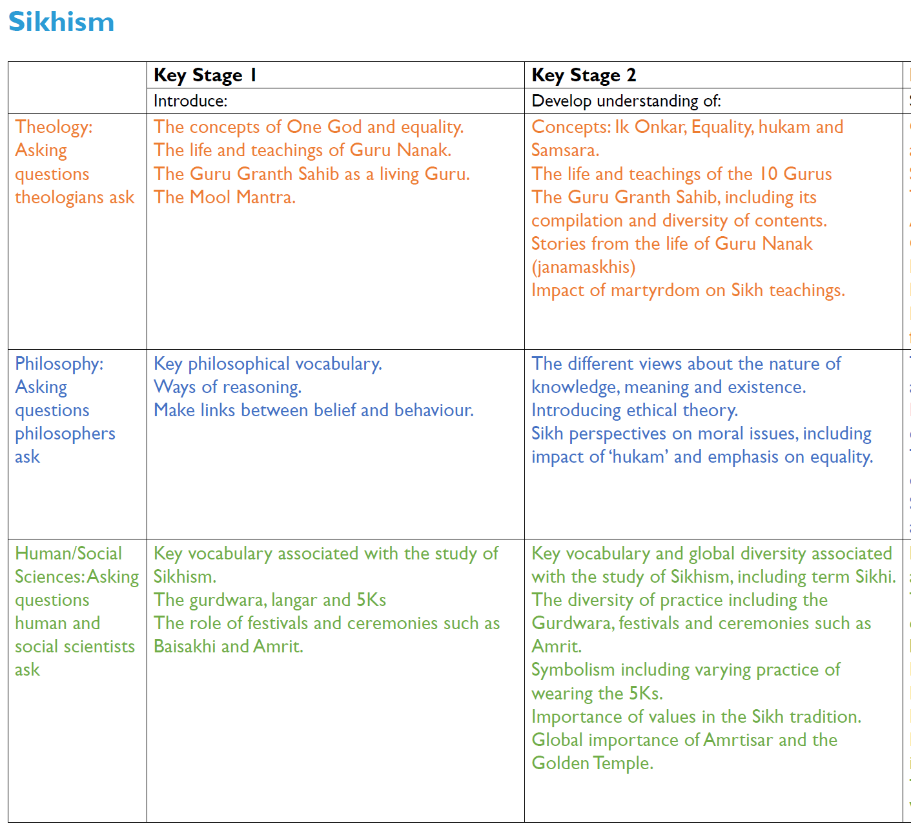
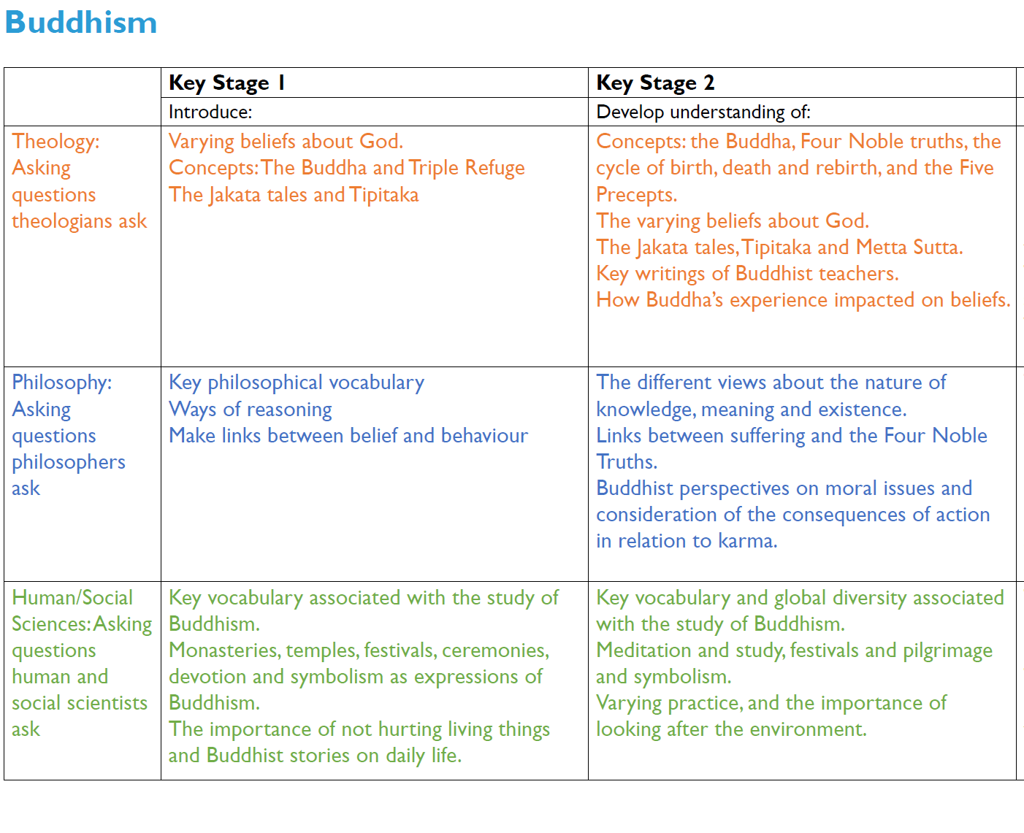

Section 5 – Vocabulary:

Religion/Worldview | Key Stage 1 | Lower Key Stage 2 | Upper Key Stage 2
General | Belief/believe, Know, Religion, Rules, Symbol | Ethical, Moral, Opinion, Philosopher, Suffering | Argument, Creed, Existence
Christianity | Creation, God, Jesus, Incarnation, Nativity, Salvation | Baptism, Messiah, Resurrection, Sacrifice, Sin, Trinity | Redemption,
Hinduism | Diwali | *Dharma, *Karma | Ahimsa, Atman, Brahma, Brahman, Diwali, Ganesha, Krishna, Mandira, Samsara, Supreme Reality, Trimurti
Islam | Eid, Islam | Allah, Five Pillars (Shahadah, Salah, Sawm, Zakah and Hajj), Khalifah, Mosque, Muhammad (pbuh), Prophet, Qu’ran, Ramadan, Shahadah, Tawhid, Wudu | N/A
Judaism | Bar Mitzvah, Bat Mitzvah, Dreidel, Jew, Judaism, Menorah, Mezuzah, Pesach, Shabbat, Star of David, Synagogue, Torah, Torah scroll, Yad | N/A | N/A
Humanism | N/A | *Agnosticism, *Atheism | Logic, Moral Philosophy, One Life, Rationalism

Section 6 – Writing Opportunities:
There will opportunity for writing in each unit and, where appropriate, the ‘express’ part of the five part enquiry can be shown in the following forms:
- extended answers to the ‘big question’
- presentations including scripts and speeches
- posters
- information texts including diagrams
- poetry
- descriptive writing
- stories containing the knowledge learned
- non-chronological reports

Section 7 – Long Term Plan
 | Autumn 1 | Autumn 2 | Spring 1 | Spring 2 | Summer 1 | Summer 2
Reception | Noah’s Ark  story  beliefs, Bible, Christian, God, religions, symbol  CW Songs:  ‘The Animals Went in Two by Two’  ‘Arky Arky’  ‘Who Built the Ark?’  ‘Mister Noah Built an Ark’  Diwali  November 12th, 2023  The Story of Rama & Sita  beliefs, Hinduism, celebration, festivals, religions, different | Christmas  The Christmas Story  beliefs, bible, celebration, Christian, Christmas, festivals, God, religions, symbols |  | Easter  March 31st, 2024  beliefs, Bible, similar, festivals, God, Christian, Easter, religions, symbols  CW Song: ‘The Lord of the Dance’
Year 1 | Christianity  How do Christians belong to their faith family?  Recognise that people have different beliefs and that some people follow religions and others non-religious worldviews; Recognise some of the symbols, artefacts and practices used by Christians in the local area; recognise that beliefs can have an impact on a believer’s daily life, their family or local community. | Christianity  What does the Nativity story teach Christians about Jesus?  Give a clear, simple account of at least one narrative, story or important text used by Christians; recognise that narratives, stories and texts used by Christians contain beliefs; give an example of how Christians use beliefs to guide their daily lives. | Judaism  Why do Jews celebrate Passover (Pesach)?  Recognise that people have different beliefs and that some people follow religions and others non-religious worldviews; recognise some of the symbols, artefacts and practices used by Jewish people in the local area; recognise that beliefs can have an impact on a Jew’s daily life, their family or local community. |  | Christianity  What does the cross mean to Christians?  Give a clear, simple account of the Easter story; recognise that the Easter story contains beliefs; give an example of how Christians use beliefs to guide their daily lives. | Christianity/Multi  How did the universe come to be?  Ask questions about the world around them and talk about these questions; give a simple reason using the word ‘because’ when talking about religion and belief; use religious and belief stories to talk about how beliefs impact on how people behave; recognise that beliefs can have an impact on a believer’s daily life, their family or local community.
Year 2 | Multi  What do the senses tell me about the world of religion?  Talk about the questions a story or practice from a religion or worldview might make them ask about the world around them; Talk about what people mean when they say they ‘know’ something; Give a reason to say why someone might hold a particular belief using the word ‘because’. | Multi  Why is light an important symbol? (for Christians, Jews and Hindus)  Retell a narrative, story or important text from at least one religion or worldview and recognise a link with a belief.  Recognise different types of writing from within one text. Give different examples of how a religion’s beliefs influence daily life; Identify ways in which beliefs can have an impact on a believer’s daily life, their family or local community | Judaism  What do Jews remember on Shabbat?  Retell a narrative, story or important text from at least one religion or worldview and recognise a link with a belief.  Recognise different types of writing from within one text.; Recognise that some beliefs connect together and begin to talk about these connections; Give different examples of how Jews’ beliefs influence daily life |  | Multi  What questions do religious stories make us ask? Can we find any answers?  Talk about the questions a story or practice from a religion or worldview might make them ask about the world around them; Give a reason to say why someone might hold a particular belief using the word ‘because’; Using religious and belief stories, make connections between peoples’ beliefs about right and wrong and their actions. | Multi  How does a celebration bring a community together?  Recognise the names of different religions, religious beliefs and worldviews and use them correctly; Identify evidence of religion and belief especially in the local area; Identify ways in which beliefs can have an impact on a believer’s daily life, their family or local community; – Give different examples of how ___ beliefs influence daily life
Year 3 | Islam  What difference does being a Muslim make to daily life?  Identify some of the ways people use the terms ‘religion’ and ‘belief’ when exploring religions; identify some similarities and differences in how people practise and express beliefs within Islam; identify a range of ways in which beliefs can have an impact on a Muslim’s daily life, their family, community and society. | Christianity/Multi  What do we mean by truth? Is seeing believing?  Recognise that there are many different religious and non-religious answers to questions people raise about the world around them; talk about the difference between knowing and believing; decide if a reason or argument based on a religion or belief makes sense to them and is expressed clearly, using more than one reason to support their view. | Christianity  Why is there so much diversity in believe in Christianity?  Identify some of the ways people use the terms ‘religion’ and ‘belief’ when exploring Christianity; identify some similarities and differences in how Christians practise and express beliefs; identify a range of ways in which a Christian’s beliefs can have an impact on their daily life, their family, community and society. |  | Islam  What do Muslims believe about God?  Show awareness of different sources of authority and how they link with Muslims’ beliefs; show awareness of some of the similarities and differences within Islam; recognise ways in which beliefs might make a Muslim think about how they live their life, how they see the world in which they live and how they view others. | Multi  What does sacrifice mean?  Recognise that there are many different religious and non-religious answers to questions people raise about the world around them; recognise that it is difficult to define ‘right’, ‘wrong’, ‘good’ and ‘bad’.
Year 4 | Christianity  What is Philosophy?  Recognise that there are many different religious and non-religious answers to questions people raise about the world around them  Talk about the difference between knowing and believing.  Decide if a reason or argument based on a religion or belief makes sense to them and is expressed clearly.  Use more than one reason to support their view.  Recognise that it is difficult to define ‘right’, ‘wrong’, ‘good’ and ‘bad’.  Recognise some of the similarities and differences between these ideas. | Christianity  What do Christians learn from the Creation story?  Identify some of the ways people use the terms ‘religion’ and ‘belief’ when exploring religions, beliefs and worldviews.  Identify some similarities and differences in how people practise and express beliefs both within and between at least two different religions/worldviews.  Identify a range of ways in which beliefs can have an impact on a believer’s daily life, their family, community and society. | Christianity  Why do Christians call the day Jesus died Good Friday?  Show awareness of different sources of authority and how they link with beliefs.  Identify different types of writing and give an example of how a believer might interpret a source of authority  Recognise that beliefs are influenced by events in the past and present  Identify some links between beliefs being studied within a religion or worldview.  Show awareness of some of the similarities and differences between and within religions and worldviews. |  | Multi  How do religious groups contribute to society and culture?  Identify some of the ways people use the terms ‘religion’ and ‘belief’ when exploring religions, beliefs and worldviews.  Identify some similarities and differences in how people practise and express beliefs both within and between at least two different religions/worldviews.  Identify a range of ways in which beliefs can have an impact on a believer’s daily life, their family, community and society. | Christianity  What is the Trinity?  Show awareness of different sources of authority and how they link with beliefs.  Identify different types of writing and give an example of how a believer might interpret a source of authority  Recognise that beliefs are influenced by events in the past and present  Identify some links between beliefs being studied within a religion or worldview.  Show awareness of some of the similarities and differences between and within religions and worldviews.
Year 5 | Christianity/Islam  How has belief in Christianity and Islam impacted on Art and Music through history?  Describe ways in which beliefs shape the way Christians and Muslims view the world in which they live and how they view others; explain the different ways in which the terms ‘religion’ and ‘belief’ are used by Christians and Muslims; explain how beliefs impact on and influence individual lives, communities and society, and how individuals, communities and society can also shape beliefs. | Multi  Is believing in God reasonable?  Explain different philosophical answers to questions about the world around them, including questions relating to meaning and existence; explain some of the different ways in which philosophers understand abstract concepts; explain whether a position or argument is coherent and logical; link a range of different pieces of evidence together to form a coherent argument. | Christianity  What difference does the resurrection make to Christians?  Describe different sources of authority and how they link with beliefs; describe a range of different interpretations of sources of authority and consider the reliability of these sources for Christians; describe ways in which beliefs shape the way Christians view the world in which they live and how they view others. |  | Christianity  What is the Eucharist and why is it important?  Explain the different ways in which the terms ‘religion’ and ‘belief’ are used by Christians; show awareness that talking about religion and belief can be complex; explain how Christians’ beliefs impact on and influence lives, communities and society, and how individuals, communities and society can also shape beliefs. | Christianity/ Humanism  Creation or Science: Conflicting or complementary?  Describe different sources of authority and how they link with beliefs; describe a range of different interpretations of sources of authority and consider the reliability of these sources for a group of believers; describe some of the key theological similarities and differences between and within religions and worldviews; explain different philosophical answers to questions about the world around them, including questions relating to meaning and existence.
Year 6 | Christianity  Was Jesus the Messiah?  Explain different sources of authority and the connections with beliefs; Begin to discuss the reliability and authenticity of texts that are authoritative for a group of believers; Explain how events in history and society have influenced some religious andnon-religious worldviews; Begin to analyse and evaluate whether a position or argument is coherent and logical and show increasing awareness of divergence of opinion | Hinduism  What difference does being a Hindu make to daily life?  Explain the key theological similarities and differences between and within religions and worldviews; Begin to analyse and evaluate a range of different answers to ethical and moral questions/issues, showing an understanding of the connections between beliefs, practices and behaviour; Begin to analyse and evaluate the varying ways in which religions and beliefs are practised locally, nationally and globally (both within and between worldviews) with reference to at least two different religions/worldviews; Begin to analyse and evaluate how beliefs impact on, influence and change individual lives, communities and society, and how individuals, communities and society can also shape beliefs | Multi  What does it mean to be human?  Is being happy the greatest purpose in life?  Begin to analyse and evaluate a range of philosophical answers to questions about the world around them, including questions relating to meaning and existence; Begin to analyse and evaluate different ways in which philosophers understand abstract concepts; Use well-chosen pieces of evidence to support and counter a particular argument; Begin to analyse and evaluate the varying ways in which religions and beliefs are practised locally, nationally and globally (both within and between worldviews) with reference to at least two different religions/worldviews |  | Hinduism  How do Hindus talk about God?  Explain different sources of authority and the connections with beliefs; Begin to discuss the reliability and authenticity of texts that are authoritative for a group of believers; Explain connections between different beliefs being studied and link them to sources of authority using theological terms; Explain and discuss how beliefs shape the way Hindus view the world in which they live and how they view others | Multi  Why is suffering in this world?  Explain and discuss how beliefs shape the way Christians and Buddhists view the world in which they live and how they view others; Begin to analyse and evaluate a range of philosophical answers to questions about the world around them, including questions relating to meaning and existence; Begin to analyse and evaluate a range of different answers to ethical and moral questions/issues, showing an understanding of the connections between beliefs, practices and behaviour; Begin to analyse and evaluate how beliefs impact on, influence and change individual lives, communities and society, and how individuals, communities and society can also shape beliefs

Theology | Philosophy | Human/Social Sciences

Section 8 – Examples of ‘deeper thinking’ questions

The following are examples of the types of questions that can be used to deepen children’s learning. They are not exhaustive and could be applied to different religions.

Why do you think…?
What conclusions can you draw about the way xxxx celebrate xxxx?
What evidence can you find that links Judaism and Christianity?
What is the relationship between Judaism and Islam?

Sources of authority include sacred texts, creeds, statements of belief, tradition, principles or rules, conscience, rational thinking.
Much of the core knowledge for humanism is taken from the following resource: https://understandinghumanism.org.uk/planning-guidelines/

