Maths through Baking – Session 3
Flapjacks and Geometry
🛡️ Keeping Children Safe: What Every Parent Should Know

What is PREVENT?
PREVENT is part of the UK’s counter-terrorism strategy and used in schools by staff. It aims to:
- Safeguard children from radicalisation
- Support those at risk of being drawn into extremism
- Promote safe, inclusive communities (links into British Values)
- Remind staff and parents that there are many backgrounds, genders, differing religious views and ethnicities that could be radicalised.

Signs to watch for:
- Sudden changes in behaviour or beliefs
- Isolation from family and friends
- Fixation on conspiracy theories or extremist ideologies

What is Grooming?
Grooming is when someone older builds trust with a child to exploit or abuse them (vulnerable adults can also be groomed). In Norfolk, we also have issues of ‘County Lines’: County lines is a form of criminal exploitation where gangs use children or vulnerable people to transport drugs and money from cities/towns to smaller rural areas, or across the county borders over Suffolk, Cambridgeshire or Lincolnshire.

Grooming can be:
- Online or in person
- By strangers or people they know
- Over weeks or even years
- Online influencers can also never have to ‘meet’ your child in order to influence them. Most famous examples are Andrew Tate, but there are also many other websites and TikTok creators who promote things such as eating disorders, self-harm or extreme ideologies.

Tactics used by groomers:
- Giving gifts, alcohol, money or attention (a sense of belonging)
- Pretending to be a friend or romantic interest
- Isolating the child from others
- Using secrecy, guilt, or threats of violence to control them

Signs to watch for:
- Going missing for periods of time or being found far from home
- Unexplained money, clothes, or phones
- New friendships with older individuals
- Increased secrecy, especially around phone use

How You Can Support your Child
- Talk regularly with your child about their online and offline lives; reassure them that they can always come to you without fear
- Know the signs of manipulation and exploitation
- Talk openly with your child about risks and peer pressure; encourage critical thinking and open conversations about beliefs and influences

Need Support or Advice?
NSPCC Helpline: 0808 800 5000 https://www.nspcc.org.uk/what-is-child-abuse/types-of-abuse/grooming/
Childline: 0800 1111 www.childline.org.uk/info-advice/bullying-abuse-safety/online-mobile-safety/online-grooming/
or you could call Norfolk County Council’s Safeguarding team: 0344 800 8005
Quadrilaterals children need to know by Year 6 (and their properties!)
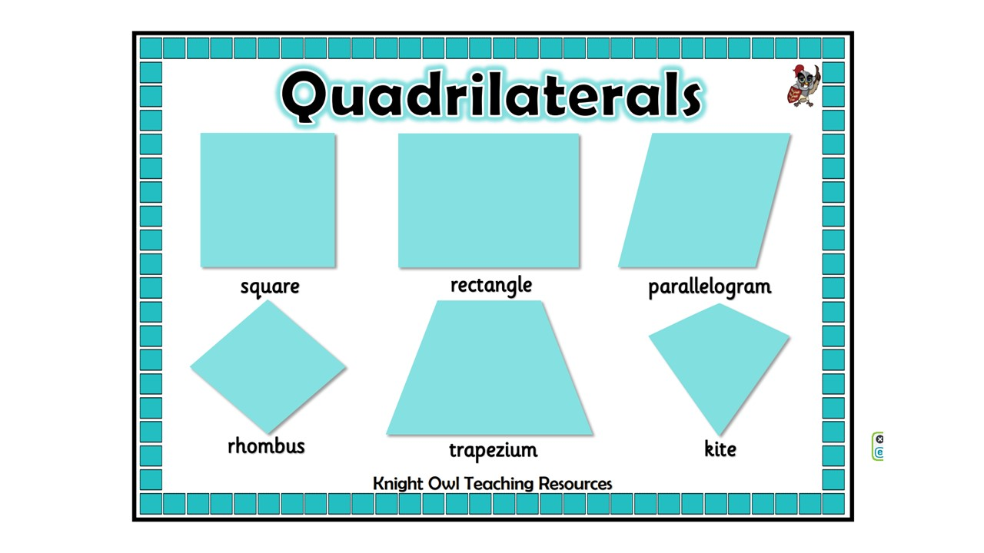
Right-Angled ‘Stiff’ Quadrilaterals
Square – Has all right angles and all sides are the same length
Rectangle – Has all right angles and its opposite sides are the same length.
n.b. technically a rectangle is any quadrilateral with four right angles (hence the name). The shape we call a rectangle is actually called an oblong. However, in recent times – and on the National Curriculum – the word rectangle is used exclusively to make things more simple.

Quadrilaterals ‘on the wonk’
Rhombus – A square on the wonk. Has all sides the same length but doesn’t have right angles. This shape can also be called ‘a diamond’. The opposite angles will always be exactly the same (KS3+)
Parallelogram – A rectangle on ‘the wonk’. No right angles but has opposite sides that are the same length. The opposite angles are exactly the same (KS3+), meaning that the sides are parallel with each other.

The other two
Trapezium – A quadrilateral which can have no right angles, one or two; and sides that can be different lengths. The stand-out with this shape is that two of the sides (and only two) have to be parallel with each other. Commonly looks like the picture above where it looks like a circus tent – and circus tents have a trapeze at the top. However, a trapezium doesn’t always look like that one.
n.b. in the UK, this shape is called a trapezium. In the US, it’s called a trapezoid. This can be a common ‘SATs trap’.

Kite – A quadrilateral which may or may not have right angles. A kite is like a rhombus/diamond but where the touching sides are the same length, not the opposite sides.

Area of 2D shapes

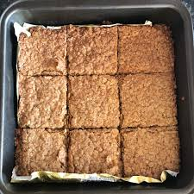
Areas of quadrilaterals
To measure inside a quadrilateral, we have to pretend we are filling it with lots of little squares. This tray has 3 flapjacks across and 3 flapjacks high.
We could either count the number of flapjacks inside, or as a shortcut, we could just do 3 x 3.
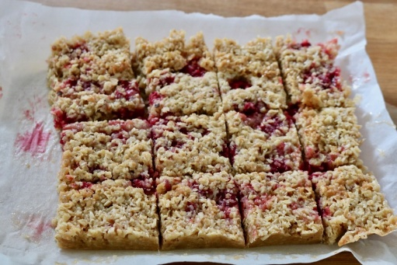
This one would be 3 x 4 (or 4 x 3)

Areas of Triangles
For every triangle, if you doubled it and put it together, it would make a quadrilateral.
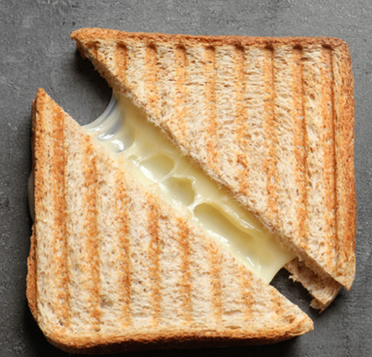
Therefore, if we have a triangle and need to work out its area, we have to pretend it’s a square or rectangle and then we can work it out. But then have to halve the amount after we’ve done so.
10cm²
20cm²

This triangle has 4cm on the bottom and 5cm at the side. If we pretended there were two of them, this would make a rectangle that was 4cm x 5cm, meaning it would be 20cm² altogether. However, as we just want one of the triangles, each one would be worth 10cm²

Flapjacks
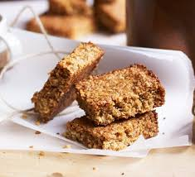
Ingredients
- 250g jumbo porridge oats
- 125g butter (plus extra for the tin)
- 125g light brown sugar
- 2-3 tbsp golden syrup
(depending on how gooey you want it)

Method
- Turn the oven on to warm up – 180°C
- Grease a 30cm x 15cm tin and line it with baking paper
- Put the oats, sugar, butter, and syrup together in a bowl & mix well until everything is combined.
- Now add any extras (chocolate chips, raisins, etc). The healthier the better!
- When everything is well-mixed tip it into the lined baking tin and spread the mixture out. With the back of a spoon pack it down as tightly as you can, making sure you also push it right into the corners.
- Put into the middle of a preheated oven for 18-20 minutes.

Healthier Flapjacks

Ingredients
- 250g jumbo porridge oats
- 2 ripe bananas, well mashed (or 200g unsweetened apple purée)
- 80ml neutral oil (rapeseed or sunflower)
- 80–100g dried fruit (raisins, sultanas, chopped dates, apricots)
- 1 tsp cinnamon (optional but very helpful flavour‑wise)
- Optional extras: grated apple, seeds, desiccated coconut

Method
- Heat oven to 180°C
- Line and lightly oil the same tin you used for the other batch
- Mash bananas (or use apple purée) in a large bowl
- Stir in oil, oats, dried fruit, cinnamon, and any extras
- Mix until everything is evenly coated and sticky
- Press firmly into the tin — really pack the corners
- Bake for 20–22 minutes
- Cool for at least 15 minutes before cutting

