Maths through Baking – Session 4
Pizza and Circles/Angles
Equality, Diversity and Inclusion in Children’s Books:
Our literary tradition comes from all over the world, not just Britain:
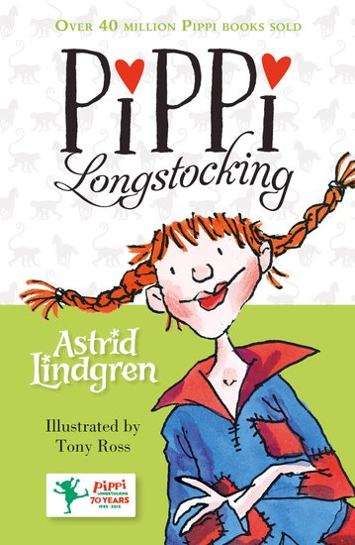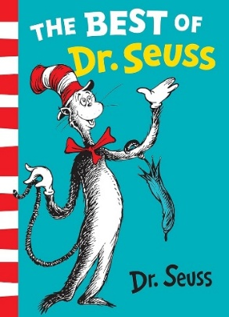
Sweden USA Japan

Books can deal with discrimination or a feeling of ‘being different’:
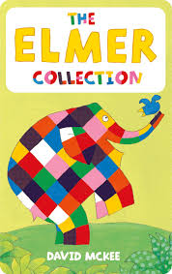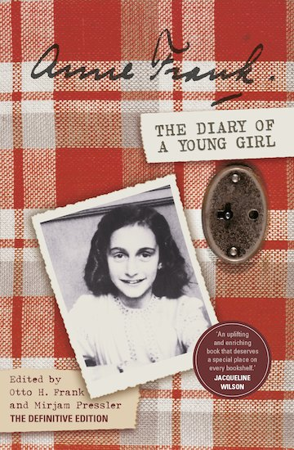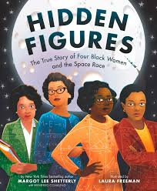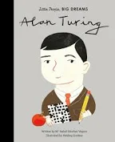
Elmer – a different elephant; Anne Frank’s Diary; Hidden Figures and how a team of black, female mathematicians helped America win the space race – and then ignored; Alan Turing who helped win WW2 but was criminalised for being gay.

Books can show morals and treating people with respect:
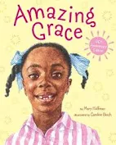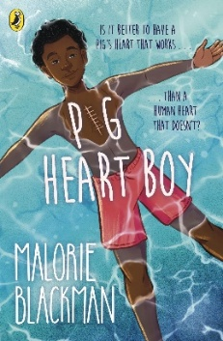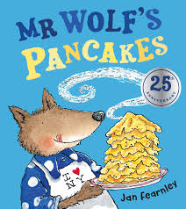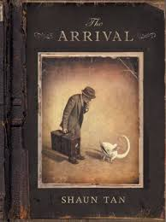
Amazing Grace – a black girl who wants to audition for the role of Peter Pan, and told by everyone she can’t; Pig Heart Boy –a teenager who goes through an experimental transplant that saves his life – but he faces bullying and media shaming; Mr Wolf’s Pancakes – picture book about Mr Wolf trying to cook pancakes and finding no-one will help him; The Arrival – a picture book with no words about emigration and escaping atrocities.

Protected characteristics are nine things about a person the law protects – like age, disability, gender, race, or who they love. For instance, you cannot be fired from work as soon as you turn 35, or a school cannot exclude two mums who are married to each other from a celebration assembly.
The nine protected characteristics (with a children’s story that goes with it!) are:
1. Age – Tiger Who Came to Tea  2. Disability - Elmer  3. Gender Reassignment – Introducing Teddy  4. Marriage/Civil Partnership – And Tango makes 3  5. Pregnancy & Maternity – Very Hungry Caterpillar | 6. Race – Amazing Grace  7. Religion or Belief – Lion, Witch & Wardrobe  8. Sex/Gender – Zog/Paper Bag Princess  9. Sexual Orientation – Julian at the Wedding

5. The Why of Pi
Pi in circles actually came before the Greeks. The Ancient Babylonians realised that if you took any circle and rolled it into a straight line, the original circle could always fit on that line three times.
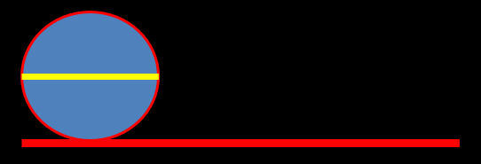
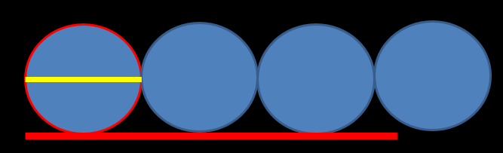
However there was a tiny bit left over and the Greeks were the ones to work out that rather than just being 3 times as long, it was actually 3.14!

The term ‘Pi’ was not invented by the Greeks but by a Welshman called William Jones in the 1700s. It is Pi for perimeter. It’s basically saying “the outside of any circle is always 3.14 x the width”

Let’s go Babylonian and just say every circle’s outside is 3x its width!
- A circle is 10cm wide. How long is its perimeter outside?
- A circle is 5cm wide. How long is its perimeter outside?
- A circle is 300cm wide. How long is its perimeter outside?

The dreaded radius is half of the width of the circle; a bit like a clock or – very handily! – a radar!
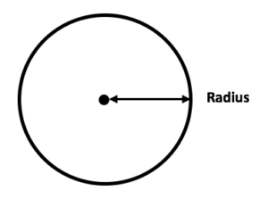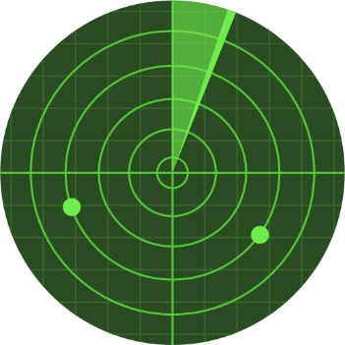

Angles
It’s really easy to think of angles as things inside shapes. The only time you ever see angles in school is staring at pages of triangles.
However, in real life, angles are used for direction – think of a compass on a ship or if someone is directing you to a shop (“go straight, then turn left, then keep going” etc)
Angle | What it is: | How to remember it:
Right Angle  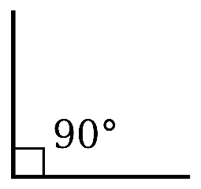 | A turn that goes directly away from a straight line. It is drawn as a square. | It is named because if you were walking forward in a straight line, if you turn exactly to the right, you are now facing 90 degrees away. If you walk forward and turn right four times, you make a square.
Acute Angle  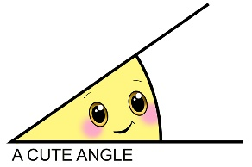 | An angle that is less than a right angle. It will be less than 90 degrees | It’s small and acute. Cute things are small.
Obtuse Angle  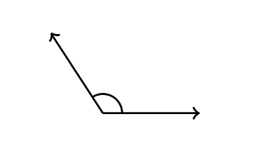 | An angle that is more than a right angle (90 degrees) but not quite 180 degrees
Reflex Angle  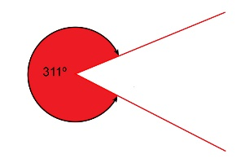 | A turn/angle that goes all the way around over 180 degrees so you are now facing to the left. | They always look like Pacman. You need good reflexes to play Pacman.
Straight Angle (not ‘a straight line’)  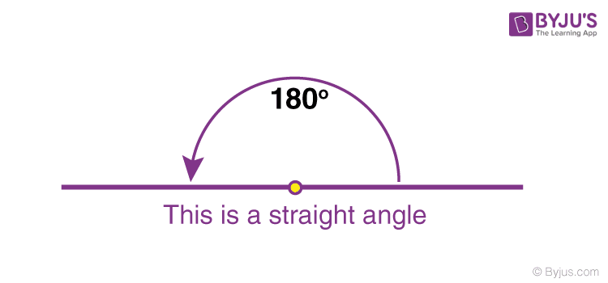 | Going from one direction and turning around and walking the exact way behind you. A ‘straight line’ would have no degrees, but a straight angle means you have gone 180˚ and facing back the way you came

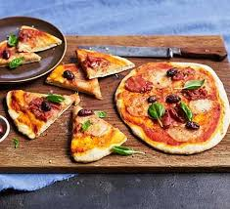
No yeast pizza dough
Makes 2 pizzas
Easy
Prep: 10 mins
Cook: 25 mins

Ingredients
- 350g plain flour
- 2 ¾ tsp baking powder
- 1 tsp salt
- 1 tbsp oil
- 170ml of water
- additional toppings
of your choice

Method
- Heat the oven to 200C/180C fan/gas 6.
- Mix together the flour, baking powder and salt in a small bowl
- Add 1 tbsp oil and most of the 170ml water then stir until it forms a ball. You can always add water – it’s much harder to take it out! If stiff, add more water, it should be soft but not sticky.
- Knead on a floured surface for 3-4 mins. Roll into 2 balls, then flatten out.
- Add toppings and bake each on a baking sheet for 15 mins.

Baking Terms:
Knead - Knead means to push and squish something soft with your hands.
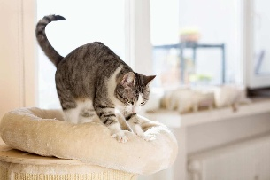
Top 10 Pizza Toppings in the World
1️⃣ Pepperoni Pizza
- Tomato sauce, mozzarella, pepperoni
2️⃣ Margherita
- Tomato sauce, mozzarella, basil
3️⃣ Hawaiian
- Ham and pineapple
4️⃣ Meat Feast
- Pepperoni, ham, sausage (sometimes bacon)
5️⃣ BBQ Chicken
- Chicken, BBQ sauce, red onion
6️⃣ Vegetarian / Veggie Supreme
- Peppers, onions, mushrooms, sweetcorn, olives
7️⃣ Four Seasons (Quattro Stagioni)
- Ham, mushrooms, olives, artichokes (in sections)
8️⃣ Four Cheese (Quattro Formaggi)
- Mozzarella plus other cheeses
9️⃣ Seafood Pizza
- Tuna, prawns, anchovies (varies by country)
🔟 Pepperoni & Mushroom
- A classic combo ordered worldwide

