Rapunzel
English
Martha Maps it out -
Leigh Hodgkinson
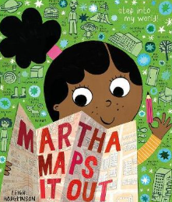
Science
To name and describe a range of common animals including humans.
Maths
Place Value (numbers to 20), Addition and Subtraction (to 20)
Year 1
Spring 1

Computing

Create text and store images
Design & Technology
Design and build a house

Geography
Walk around Great Yarmouth

PSHEE Education
PSHE – Diverse Britain
RSE – My Relationships

Physical Education & Games
PE - Gymnastics
Games – Multi-skills
Religious Education
Why do Jews celebrate Passover (Pesach)?

Music
Exploring Sounds

